（格式範例）水庫排砂即時操作之研究
林郁雯¹ | 游景雲²*
1. 國立臺灣大學土木工程學系碩士
2. 國立臺灣大學土木工程學系教授
* 通訊作者，Email: genejyu@mail.ntu.edu.tw
摘要
本研究旨在解決不確定入流下，水庫即時排砂操作策略之擬訂，建立即時最佳操作模式以決策水庫排砂操作。為取得水庫於排砂與蓄水兩大目標間之平衡，模式操作目標包含有(1)使水庫排砂量最大化及(2)使水庫最終蓄水量達所訂定之目標蓄水量。為考量入流之不確定性，本研究透過序率規劃找出最佳操作策略，並考量不同因子對操作結果之影響。本研究假設濃度於空間上為均勻分布以簡化濃度之計算。首先建立兩階段序率規劃模式(2-stage stochastic programming)，研究目標函數特性及主要影響因子，並將模式延展至長時間操作。之後將模式修正為多階段序率規劃模式(multi-stage stochastic programming)，並透過簡化後之目標函數進行最佳決策以提高操作之效益與計算之效能。最後研究不同入流量-入流濃度關係對於水庫操作之影響，並提出一最佳水庫排砂操作策略。
關鍵詞：排砂操作、即時操作、序率規劃、水庫操作策略、水庫蓄水與泥砂控制
The Framework of Real Time Sediment Flushing Operation
Yu-Wen Lin¹ | Jiing-Yun You²*
1. Master, Department of Civil Engineering, National Taiwan University
2. Professor, Department of Civil Engineering, National Taiwan University
* Corresponding Author, Email: genejyu@mail.ntu.edu.tw
Abstract
Reservoir sedimentation is a serious problem with large environmental and economic implications. The sedimentation significantly decreases the reservoir capacity and reduces benefits. To maintain the reservoir capacity, is an effective practice. However, the real-time sediment flushing operation is still not well studied yet. Although the goal is very obvious, store clear water and release the muddy water, the difficulty of sediment flushing operation is from the uncertainty of both inflow and sediment discharge. The two objectives of operation are: (1) maximization of the total flushing sediment volume, and (2) reaching the objective storage after the flood event. The decision variables are release volume during operation period. To simplify the problem of concentration distribution, we assume that the concentration is uniform in space. Considering the uncertainty, two-stage stochastic programming was established to study the relationship between reservoir concentration and release volume. Then reservoir operation optimization model was developed for operation decision in two ways: (1) time period extension of two-stage stochastic programming model, and (2) multi-stage stochastic programming model. According our models, the purpose of this study is to propose an optimal reservoir operation policy for flushing sediment.
Keywords: Sediment flushing, Real-time operation, Stochastic programming, Reservoir operational policy, Storage control and sediment control of a reservoir

- INTRODUCTION
Reservoir sedimentation is a natural process which causes a common problem worldwide. Because the construction of a dam blocks the sediment discharge to downstream, sediment carried into a reservoir will be deposited and causing bed aggradation and reduction of storage capacity. The loss of capacity limits functionality and diminishes the lifespan of the facility (Lee and You, 2013). Moreover, with the impact of climate change, the potential sediment yield in a reservoir could be increasing in coming future, and imposes challenges to reservoir management and operation (Goode, 2012). Huang and Makar (2013) assessed the impacts of climate changes on reservoir sedimentation with five climate change scenarios projecting on Elephant Butte Reservoir, and found that the sediment loads would increase in the wetter and less warming scenario in the future, thus affecting the lifespan of the reservoir. Due to the tremendous adverse impact of dam on environment and ecosystem, practically it is very difficult to build a new large dam nowadays (Parekh, 2004; Qi et al., 2005; Wei et al., 2009). As a result, how to maintain the reservoir, especially its capacity by reducing sediment deposits becomes a critical issue for sustainable reservoir management.
To maintain the reservoir capacity, engineers have applied various approaches for reservoir sedimentation control. These approaches can be categorized to 1) dredging and siphoning, 2) sediment routing during floods, 3) sediment flushing (drawdown flushing and emptying flushing), and 4) turbidity current venting (Fan and Morris, 1992; Shen, 1999; Wang and Hu, 2009). Among these approaches, sediment flushing is an effective practice in sediment release with low economic cost, which has been applied successfully in many cases (Lai and Shen, 1996; Chang et al., 2003; Wang and Hu, 2009). Most of the investigations focus on the mechanism and properties of sediment flushing (Lai and Shen, 1996; Atkinson, 1996), and availability and effectiveness in reservoirs by construction of physical models (Hotchkiss, 1990; Ashraf et al., 2014) and simulation models (Castillo et al., 2014). However, less studies discussed the reservoir operation for sediment flushing. Chang et al. (2003) revealed that the operators usually take the flushing operation as a matter of experience instead of an operating rule.
Recently, to sustain the utilization of reservoirs, the studies have adjusted the direction from the application of flushing measures to the determination of flushing operational policies. Chang et al. (2003) and Khan (2009) developed optimization-simulation models by genetic algorithm (GA) to optimize the yearly rule curves considering with sediment removal. Shokri et al. (2012) presented a stochastic dynamic programming (SDP) model to determine monthly water release in different scenarios for meeting water demand and sediment flushing. Shen (1999) and Chang et al. (2003) suggested that sediment flushing operation could be taken during a flood event considering both water storage and sediment flushing. Wan et al. (2010) proposed a similarity-based operation model consisting of water and sediment process forecasting to improve the efficiency of reservoir operating strategy for water saving and sediment flushing during a flood event; however, the operating rule is deterministic by a sediment concentration threshold.
Shen (1999) recommended that the ideal operation for sediment flushing in a flood event could be opening the outlet before the peak of sediment inflow then closing the outlet before the peak flow discharge; nevertheless, the flushing efficiency would depend on the relationship between the time variations of inflow and sediment inflow. Williams (1993) categorized the relations into five major classes according to the ratios of sediment concentration to water discharge in the hydrologic events, including single-valued, clockwise loop, counterclockwise loop, single-valued relation plus a loop, and figure eight. Megnounif et al. (2013) claimed that the most frequent floods are clockwise loop and counterclockwise loop. Unfortunately, the influence of the inflow relationship on the sediment flushing operation or operating policy is unclear.
In previous studies, the framework of real-time reservoir operation for sediment flushing during a flood event has never been well studied, and a more general reservoir operating policy should be declared. Therefore, the purpose of this study is to develop a simplified model to optimize the real-time reservoir operation for sediment flushing during flood events under the consideration of water storage, and propose a reservoir operating policy. Based on real-time inflow forecasting, the operational model dynamically determines the optimal water release by SDP with the assumption of uniform spatial distribution of concentration. The uncertainties of both inflow discharge and sediment inflow are represented by an ensemble of possible inflow in the future. To discuss the affection of the relationship between inflow and sediment inflow on the sediment flushing operation and carry out the reservoir operating policy, the model is applied in four inflow types. Then two case studies are presented in the Shihmen Reservoir to evaluate the performance of the model and demonstrate the effectiveness of the operational policy.
- MODEL FORMULATION
2.1 Model Description
The operation model aims to find the appropriate time to discharge and determine the optimal release policy to flush out sediment as much as possible in a flood event considering water storage. This model assumes a single reservoir with effective capacity (S_{max}), storage (S_{t-1}) and concentration (C_{t-1}), the inflow discharge (I_{t}) and its concentration (CI_{t}) varies with time, and we need to decide water release R_{t} in each time period to flush out sediment under the uncertain inflow conditions (Fig. 1). The storage S can be obtain by the continuity equation
, , (1)
where i indicates the inflow prediction event, and I_{t}^{i} is the measured inflow I_{t}. To simplify the problem of sediment distribution, this research assumes the concentration distribution to be uniform in space. Hence, the reservoir concentration C can be expressed as
, . (2)
Then the model determines the optimal water release by solving the objective function considering with inflow prediction to ensure that the storage at the end of the flood event can refill to the objective storage (S_{obj}) and to avoid overflow. Because that the release decisions depend on uncertain inflow data, this study uses stochastic programming to solve the problems. First, we develop the model in two-stage stochastic programming to illustrate the form of the objective function and study its properties, then extend the model to long term operation by rolling decision making. Finally, we reform the model in multi-stage stochastic programming to improve the decision-making ability.
Period t
Period t+1
Period t+2
S_{t-1}, C_{t-1}
S_{t}, C_{t}
I_{t}, CI_{t}
R_{t}
τ = t
Stage 1
S_{t+1}, C_{t+1}
I_{t+1}^{i}, CI_{t+1}^{i}
R_{t+1}^{i}
τ = t+1
Stage 2
S_{t+2}, C_{t+2}
I_{t+2}^{i}, CI_{t+2}^{i}
R_{t+2}^{i}
τ = t+2
Stage 3
...
Fig. 1. Description of the model decision process.
2.2 Two-stage Stochastic Programming
In two-stage stochastic programming (TSP), the decision is first made without full information and the uncertainties (random events) are excluded, which is first-stage decision. After the random events are known, the second-stage decision is taken with the result of first-stage decision and uncertainties in second stage to optimize the objective function (Birge et al., 1997; Li et al., 2005). In this study, to discharge sediment as much as possible, the objective function is the maximization of total sediment outflow in two stages, and the decision variables are the water release in each stage. Hence, the formulation of the two-stage model can be expressed as equation 3:
, (3)
where the first-stage release decision (R_{t}) is determined by the reservoir initial data (S_{t-1}, C_{t-1}) and measured inflow data (I_{t}, CI_{t}) in current period, and the second-stage release decision (R_{t+1}) is influenced by the result of first-stage decision (S_{t}, C_{t}) and forecasted inflow event i (I_{t+1}^{i}, CI_{t+1}^{i}) in next period.
The physical constraints define the upper and lower bounds of the storage and water release. The storage in each stage ranges from 0 to full capacity (S_{max}), which can be written as
(4)
and
, (5)
where τ = t , t+1. Water release in each stage is not less than 0, that is
. (6)
It should be noticed that constraints 4 to 6 must be satisfied in each inflow event i in second stage (τ = t+1).
2.3 Rolling Decision Making with Two-stage
Reservoir operation is a series decision making for water release over time, which depends on reservoir state and forecasted inflow. Though the reservoir state varies with release decisions and inflow data in the future is difficult to forecast, decisions can be made by rolling procedure. Sethi and Sorger (1991) and Ryan (1998) described the procedure as following statements. At initial period, the decision maker knows the previous and current information of the system, and forecasts future information in following periods, then makes and implements decisions. After a certain time, that is the second period, the information data are updated and forecasts for additional periods are needed, and the process repeats in every periods.
This study extends the two-stage stochastic programming to long-period operation by rolling procedure as the above statements. The known data, including the previous and current information, are the reservoir state and measured inflow data in the current period. First, the model generates an ensemble of possible inflow data sets i in later stages with the normal probability distributions, where the standard deviations increase with time then maintain as constant values after a certain time. Then the model solves the optimization problem to determine the optimal release decision in current period by equations 3 to 6. To ensure the water storage and guarantee that the storage will not be too low after the flood event, equation 7 is added to the constraints:
(7)
The storage in second stage (S_{τ+1}) has to be greater than or equal to the objective storage (S_{obj}) in all forecasted inflow events, otherwise the water release should be zero, which indicates that the release operation will be implement as the storage in second stage can exceed S_{obj} in all predicted inflow event, especially the minimum inflow discharge event (I^{min}_{t+1}). Afterwards, the process repeated to the end of the flood event.
Owing to the limitation of inflow prediction in two-stage model which determines the water release based on known data in first stage and inflow forecasts in second stage, the influence of inflow in later stages to the release decision are neglect, and the water release is restricted to a certain value to ensure the water storage, however, reducing the flushing efficiency. Therefore this study develops a multi-stage stochastic programming model to enhance the performance in next section.
2.3 Multi-stage stochastic programming
In each time period t, the multi-stage model measures the current reservoir storage and concentration, and obtains the prediction of inflow discharge and concentration from the next stage t+1 to the final stage T for stochastic programming. To maximize the total amount of sediment flushing, the optimal water release in time period t is decided by the objective function as equation 8,
,(8)
where t is the current time period (t=1~T), T is the end period of the flood event, R is the water release, C is the reservoir concentration in each stage shown as equation 2. The constraints include the upper and lower bounds of storage and release decisions as equations 4 to 6. To ensure the water storage at the end of the flood event, equation 9 is used to limit the storage at the end of the flood to be greater than or equal to the objective storage S_{obj}.
(9)
Although the equations seem to be clear and simple, the calculation is very complex and consumes a lot of time. Therefore, we simplified the objective function by backward method to equation 10. The result suggests that the release decision mainly depends on the relationship between reservoir concentration and inflow concentration.
(10)
s.t. (11)
(12)
(13)
(14)
Equations 11 to 14 are the upper and lower bounds of the storage and release. To obey the purpose that the water storage at end period would not be too low especially in the forecasted inflow events with minimum inflow, we rewrite equation 9 to equation 13 that the summation of storage and the minimum predicted inflow discharge in later stages is restricted to be greater than or equal to objective storage.

- NUMERICAL EXPERIMENTS
3.1 Flood Events
To analyze the performance of the operational model and the influence of inflow relations between inflow discharge and concentration to the operation decision, we apply the model to four assumed flood events with frequent inflow hydrograph (Fig. 2) which categorized by Williams in 1993. Total inflow discharge in single flood event is often equal to the reservoir capacity in Taiwan, therefore the ratios of total inflow discharge to the capacity in four inflow types are 1 to 1. The objective storage is set to 80 percent of the reservoir capacity.

Fig. 2. Flood events with four inflow relations: (a) single-valued, (b) clockwise loop, (c) counterclockwise loop, and (d) figure eight.
This study uses two indices to evaluate the performance of the model. One is flushing efficiency (F.E.), total sediment outflow divided by total sediment inflow, and the other is the storage at the end of the flood event, S_{final}.
3.2 Two-stage Model
We first apply the two-stage model in four flood events. Fig.3 displays the four model operation results.

Fig. 3. The optimal release policy of inflow four inflow types operating by two-stage model.
It is interesting that the reservoir operations are nearly the same. The storage raises to the S_{max} first, then remains as high water level as possible for a certain period. As the reservoir concentration reaches to the maximum value, the operation discharges the maximum available water release for sediment flushing, and the storage drops down to a lower level. After that, the storage gradually rises up and achieves to S_{obj} at end period. During the operation, the reservoir might store water again after flushing sediment as a result of larger inflow concentration, which can be seen in the operation result in inflow type D.
Table 1 presents the final storage and flushing efficiency of four inflow types. According to the table, the storage can refill to 80 percent of the reservoir capacity after the flood event in all inflow types. Consistent with Shen’s inference in 1999, the flushing efficiency varies with the relations between inflow discharge and concentration. Compared with the four inflow types, the flushing efficiency of inflow type B, which is 0.93, is the best because that high inflow concentration appeared before the inflow peak, and reservoir could release turbid inflow then stored clear water. Owing to the limitation of inflow prediction in two stage model and the avoidance of water shortage, the water release is restricted to a certain value to ensure the water storage, however, reducing the flushing efficiency. To enhance the performance of the model, the multi-stage model is applied in next section.
Table 1. The final storage and flushing efficiency of 4 inflow types operating by two-stage model.
Inflow type |  |  | Flushing efficiency
A | 0.8 | 1 | 0.90
B | 0.8 | 1 | 0.93
C | 0.8 | 1 | 0.85
D | 0.8 | 1 | 0.87
3.3 Multi-stage Model
In the results of four numerical experiments (Fig. 4), the reservoir operations are nearly the same as the results operating by two-stage model. The release policy is suggested to be operated in four steps:
Step 1. Store water to fill the reservoir as the reservoir concentration is low.
Step 2. Maintain the full reservoir capacity before the arriving of peak reservoir concentration.
Step 3. Release the maximum available water release to flush out sediment after the peak of the reservoir concentration.
Step 4. Refill the reservoir.
The release peak occurs when the reservoir concentration rises to the maximum value because that the reservoir discharges as much volume as possible for sediment flushing at this time period. Generally, the reservoir concentration gradually declines after that to the end, and the reservoir refills the water to the objective storage. In some cases, for example, inflow type D, the reservoir concentration climbs again due to the higher inflow concentration, and the reservoir operation will reiterate the operation from step one to four till the end of the flood.

Fig. 4. The optimal release policy of inflow four inflow types operating by two-stage model.
Comparing the flushing efficiency in four inflow types (Table 2), the flood type B performs the best, which conforms to the result in previous section. Owing to the superior ability of inflow prediction, the achievement of multistage operation model is better than the two-stage operation model. We also change the objective storage to 90 and 100 percent of the reservoir capacity, and the operation in four inflow types obey the four-steps operational policy; however, higher objective storage results in lower flushing efficiency. Generally, high initial storage induce to good performance. In experiments, flushing efficiency is range from 0.5 to 0.6 as the initial storage is up to 70 percent of capacity.
Table 2. The final storage and flushing efficiency of 4 inflow types operating by multi-stage model.
Inflow type |  |  | Flushing efficiency
A | 0.8 | 1 | 0.93
B | 0.8 | 1 | 0.95
C | 0.8 | 1 | 0.87
D | 0.8 | 1 | 0.88
- CASE STUDY
4.1 Description of the Shihmen Reservoir
The Shihmen Reservoir, completed in 1964, is located in Taoyuan County in northern Taiwan, which features in irrigation, hydroelectricity generation, flood control and water supply regulation. The area of the Shihmen Reservoir watershed is about 763.4 square kilometers, impounding water with the upstream reaches of the Dahan River. The annual precipitation, about 2,350 millimeter, mainly concentrates in May to October, the plum rain season and typhoon season. Although rainy season could solves the problem of water shortage, torrential rain usually brings quantities of sediment into the reservoir and causes serious deposition problem. The original design capacity of the reservoir is about 309 million cubic meters; however, sedimentation reduces the active capacity to 201 million cubic meters, nearly 35 percent reduction (Water Resources Agency, 2015). To decrease the sedimentation, NRWRO (Northern Region Water Resources Office, WRA) rebuilt one of the hydro plant intake to the sediment venting tunnel and extended the discharge to 300 cms for sediment flushing in 2012, and planned to construct the other two bypass tunnels to prevent sedimentation. In July in 2013, the Shihmen Reservoir first operated the sediment venting tunnel during Typhoon Soulik, the operators opened the tunnel for sediment removal when the turbidity current passed the hydro plant intake and successfully flushed out 3.2 million tons of sediment, which was nearly four times as much as annual sediment removal by dredging and excavation in the previous year. To further confer the appropriate operation for sediment flushing in the Shihmen Reservoir, we apply the optimal operation model during Typhoon Soula and Typhoon Soulik. In each case, the maximum release discharge is less than 13,800 cms, which is the maximum spillway discharge in the Shihmen Reservoir.
4.2 Typhoon Saola
Typhoon Saola encroached on Taiwan in 2012 during July 31 to August 3 and made landfall twice, which resulted in abundant precipitation in northern Taiwan, creating 493.11 million cubic meters of total reservoir inflow and 7.65 million tons of total sediment discharge. The peak inflow with 5,588.54 cms appeared in the middle of the flood process, which was the same as the occurrence time of peak sediment inflow discharge. Figure 5(a) shows the historical operation of the Shihmen Reservoir during Typhoon Saola, the operation did not consider with sediment flushing, which was close to the inflow discharge as a result of high initial storage (83 percent of reservoir capacity). The release operation continued to August 5 because that the turbidity was too high to supply water after the flood event. Hence the total operating time was 116 hours while the all flood process was only 80 hours. At the end of the typhoon, the storage refilled to 189 million cubic meters, which is 90 percent of the effective reservoir capacity, and the flushing efficiency is 0.15.
Figures 5(b) displays the operating results of the model. The release operation for sediment flushing conforms to the 4 steps operational policy: 1) storing water to the full capacity, 2) maintaining the storage, 3) discharging for sediment flushing as the reservoir concentration rises to maximum, then 4) refilling to the objective storage. In figure 5(c), the reservoir concentration obviously decreases after the release operation in virtue of flushing sediment and storing clear inflow discharge. The total operating time is 80 hours, which is the same as whole flood process. Though the operating time is shorter than historical operating tine, the final storage can reach to the historical record (90 percent of full capacity) and the flushing efficiency is up to 0.68, which is 4 times more than that of the historical operation (Table 3).
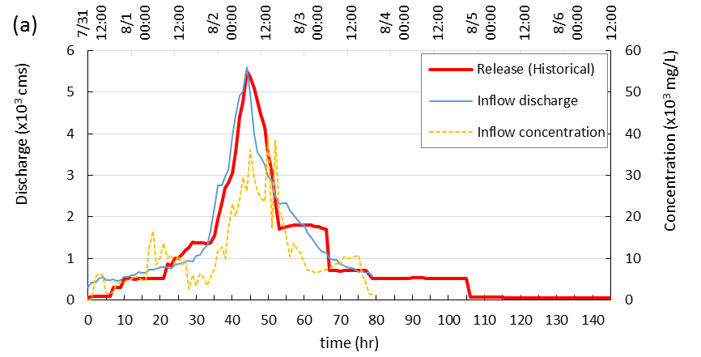
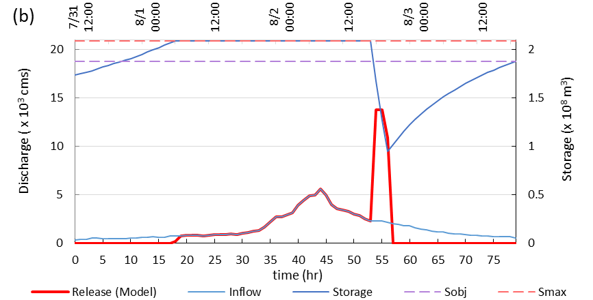
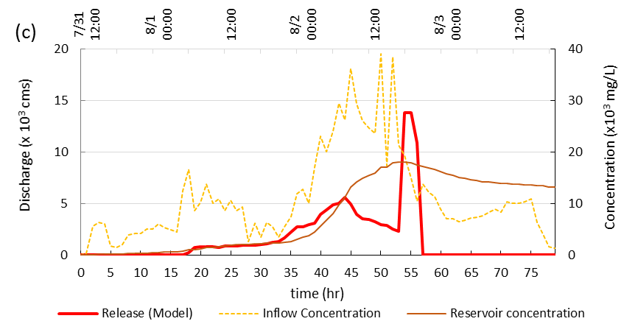
Fig. 5. (a) The temporal graph and historical operation of Typhoon Saola. (b) Release operation obtained by the model, and storage against time. (c) Reservoir concentration against time.
4.3 Typhoon Soulik
In July 12 to 14 in 2013, Typhoon Soulik intruded Taiwan, inducing 264 million cubic meters of total reservoir inflow with peak flow 5,458 cms to the Shihmen Reservoir. Though the rainfall was not as heavy as Typhoon Saola, the high inflow concentration still caused large amount of sediment, about 9.22 million tons, flowing into the reservoir. Figure 6(a) illustrates the historical operation. The operators opened the sediment venting tunnel twice for 8 hours sediment removal. The first time is at the rising limb of the inflow after the turbidity current passed the hydro plant intake. The second time is after the typhoon leaved due to high reservoir concentration, which might result in water shortage. The total amount of sediment flushing was 3.23 million tons, and the flushing efficiency was up to 0.34, which was twice as the average flushing efficiency (0.15~0.17) in previous typhoons that had not started using the sediment venting tunnel. However, the total operating time was 114 hours long, and total water release was up to 252 million cubic meters.
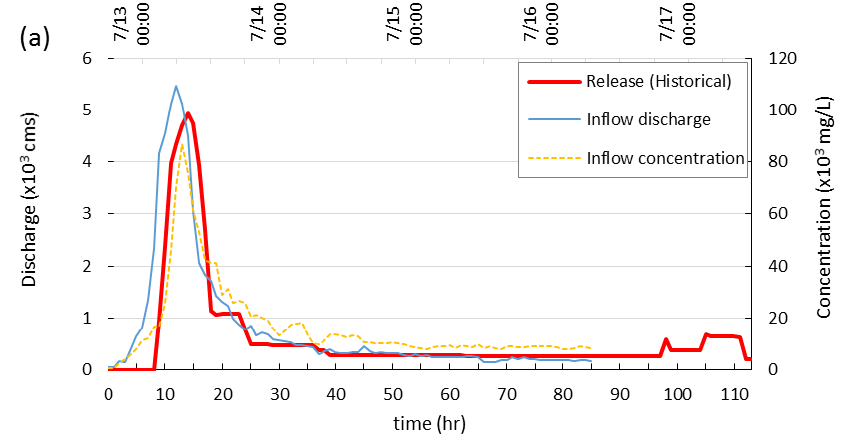
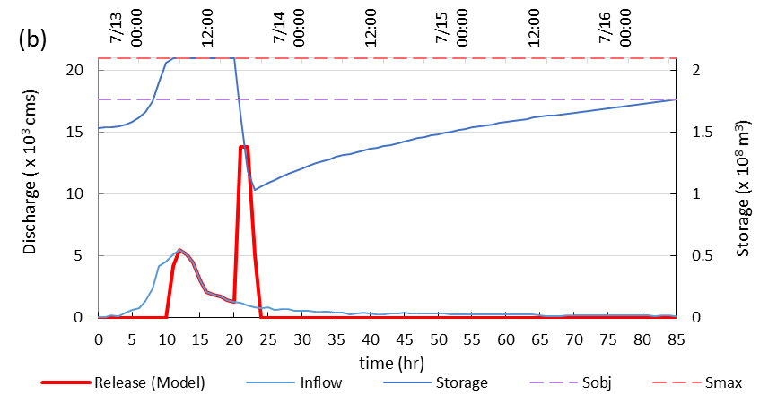
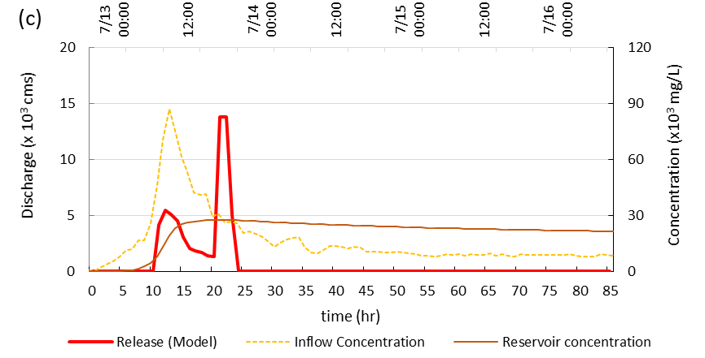
Fig. 6. (a) The temporal graph and historical operation of Typhoon Soulik. (b) Release operation obtained by the model, and storage against time. (c) Reservoir concentration against time.
In contrast with historical operating time, total operational period in the operation model is only 86 hours. The operation mainly concentrates on sediment flushing in 3 hours when the reservoir concentration rises to the maximum, which is the largest release peak in figure 6(b). The second largest release peak is to ensure the dam safety and keeps the storage at full capacity. After sediment flushing, the storage progressively refills to the objective storage by storing clear water, and the reservoir concentration gradually decreases. In this case, the operating process is accordance with the 4 steps reservoir operational policy. At the end of the flood event, the result of final storage approximates as historical record (84 percent of reservoir capacity); however, the total amount of sediment flushing (5.5 million tons) and flushing efficiency (0.59) are close to twice as that of the historical operation (Table 3).
Table 3. Simulated results of water storage and flushing efficiency for two typhoons.
Typhoon |  | Saola | Soulik
Total inflow (10⁸ m³) |  | 4.93 | 2.64
Total sediment inflow (10⁶ ton) |  | 7.65 | 9.22
Final storage (10⁸ m³) | Historical | 1.89 | 1.76
 | Model | 1.88 | 1.76
Total sediment discharge  (10⁶ ton) | Historical | 1.15 | 3.23
 | Model | 5.18 | 5.41
Flushing efficiency | Historical | 0.150 | 0.343
 | Model | 0.677 | 0.590
This chapter applied the operational model to real flood events to investigate the performance and efficiency of the operational rule. In contrast to the historical operation, the model provided better operation that flushing sediment concentrated in few hours as high reservoir concentration, and resulted in shorter operating time and better flushing efficiency under the expectation of reaching the storage of historical record after the flood event. In two cases, the flushing efficiency are greater than 0.5, which are much better than historical flushing efficiency (0.15~0.17 in average). Consequently, the operational model had good performance applying to real flood events. The operation, coinciding with the previous reservoir operational policy that releasing quantities of water as high reservoir concentration, conduces to water storage and also promotes the sediment flushing.
- CONCLUSIONS
This study proposed an optimal operation model to determine the release discharge during a flood event with the purposes of water storage and sediment flushing. The operational model first obtained the prediction of the inflow data, including the probability distribution of inflow discharge and concentration, then maximized the total sediment flushing discharge in the whole operating period on the basis of inflow prediction data and current state of the reservoir to determine the optimal water release in current time step under the expectation that the storage at end period would not be less than an objective storage to ensure water supply in the future. Considering with the inflow uncertainty, the operation model used stochastic programming to solve the objective function. To shorten the computation time, the objective function was simplified to a more effortless form. Established model by backward method, then was applied in numerical experiments with four cases which had different inflow relations between inflow discharge and concentration. According to the numerical experiments with four inflow types, the reservoir operational policy could be generalized to four steps:
(1) storing water to full capacity first,
(2) then maintaining the storage as high water level as possible,
(3) as the reservoir concentration arises to the maximum, discharging available water release as much as possible for sediment flushing,
(4) finally, restoring reservoir to objective storage.
Generally, the flushing efficiency is range from 0.5 to 0.6 as the initial storage is up to 70 percent of capacity and the total inflow is equal to or larger than the reservoir capacity. In the results of the numerical experiments, the flushing efficiency of inflow type B is the best, which could release turbid inflow in early stages and keep clear water later. This finding is in agreement with Shen’s statement.
In Taiwan, the present reservoir operation during a flood event is mainly for flood control and water storage. As the water level is too high, the outlets will be opened to spill water for maintaining water level in the flood control zone. The reservoir sedimentation problem mainly solves by dedredging and excavation, which yearly remove 0.8 million tons of sediment in average in the Shihmen Reservoir. According to this study, releasing water concentrated in few hours when the reservoir concentration rises to the maximum can successfully remove up to 5 million tons of sediment in a large flood event (total inflow is nearly equal to or larger than the reservoir capacity), which is more effective and low cost. Besides, water storage can also be ensured. In case studies, the flushing efficiency ranges between 0.5 and 0.7, which is much more than historical operational results (0.15~0.3). However, the flushing efficiency is significantly affected by reservoir capacity (or the ratio of total inflow discharge to reservoir capacity).
REFERENCES
- Lee, B. S., & You, G. J. Y. (2013), "An assessment of long-term overtopping risk and optimal termination time of dam under climate change," Journal of environmental management, 121, 57-71.
- Goode, J. R., Luce, C. H., & Buffington, J. M. (2012), "Enhanced sediment delivery in a changing climate in semi-arid mountain basins: Implications for water resource management and aquatic habitat in the northern Rocky Mountains," Geomorphology, 139, 1-15.
- Huang, J., & Paula Makar, P. E.(2013), "Reclamation’s Research on Climate Change Impact on Reservoir Capacity," World Environmental and Water Resources Congress: Showcasing the Future, pp. 1202-1212.
- Parekh, P. (2004), "A preliminary review of the impact of dam reservoirs on carbon cycling," International Rivers Network, Massachussets.
- Qi, J. Y., & Ruan, X. H. (2005), "Dam construction-induced environmental impact on riverine ecosystem," Journal of Hohai University: Natural Sciences, 33(1), 37-40.
- Wei, G., Yang, Z., Cui, B., Li, B., Chen, H., Bai, J., & Dong, S. (2009), "Impact of dam construction on water quality and water self-purification capacity of the Lancang River, China," Water resources management, 23(9), 1763-1780.
- Fan, J., & Morris, G. L. (1992), "Reservoir sedimentation. II: Reservoir desiltation and long-term storage capacity," Journal of Hydraulic Engineering, 118(3), 370-384.
- Wen Shen, H. (1999), "Flushing sediment through reservoirs," Journal of Hydraulic Research, 37(6), 743-757.
- Wang, Z.Y. & Hu, C. (2009), "Strategies for managing reservoir sedimentation," International Journal of Sediment Research, 24(4), 369–384.
- Lai, J. S., & Shen, H. W. (1996), "Flushing sediment through reservoirs," Journal of Hydraulic Research, 34(2), 237-255.
- Chang, F. J., Lai, J. S., & Kao, L. S. (2003), "Optimization of operation rule curves and flushing schedule in a reservoir," Hydrological Processes, 17(8), 1623-1640.
- Atkinson, E. (1996). The feasibility of flushing sediment from reservoirs.
- Khan, N. M., & Tingsanchali, T. (2009), "Optimization and simulation of reservoir operation with sediment evacuation: a case study of the Tarbela Dam, Pakistan," Hydrological processes, 23(5), 730-747.
- Shokri, A., Haddad, O. B., & Mariño, M. A. (2012), "Reservoir operation for simultaneously meeting water demand and sediment flushing: stochastic dynamic programming approach with two uncertainties," Journal of Water Resources Planning and Management, 139(3), 277-289.
- Wan, X. Y., Wang, G. Q., Yi, P., & Bao, W. M. (2010), "Similarity-based optimal operation of water and sediment in a sediment-laden reservoir," Water resources management, 24(15), 4381-4402.
- Williams, G. P. (1989), "Sediment concentration versus water discharge during single hydrologic events in rivers," Journal of Hydrology, 111(1), 89-106.
- Megnounif, A., Terfous, A., & Ouillon, S. (2013), "A graphical method to study suspended sediment dynamics during flood events in the Wadi Sebdou, NW Algeria (1973–2004)," Journal of Hydrology, 497, 24-36.
- Birge, J. R., & Louveaux, F. (1997), Introduction to stochastic programming. Springer Science & Business Media.
- Li, Y. P., Huang, G. H., & Nie, S. L. (2006), "An interval-parameter multi-stage stochastic programming model for water resources management under uncertainty," Advances in Water Resources, 29(5), 776-789.
- Sethi, S., & Sorger, G. (1991), "A theory of rolling horizon decision making," Annals of Operations Research, 29(1), 387-415.
- Ryan, S. M. (1998), "Forecast frequency in rolling horizon hedging heuristics for capacity expansion," European journal of operational research, 109(3), 550-558.

